 | FAQ’s  “How can Gottman Method Therapy help improve my relationship with my partner?” Gottman Method Couples Therapy is based on John Gottman’s research which is devoted to discovering the patterns of behavior that separate happy couples from unhappy couples. This research is based on scientific evidence and has demonstrated the ability to predict divorce with over 90% accuracy. Here are some of the ways Gottman Method Couples Therapy can help improve your relationship:  - Creating positive change in a couple’s interactions using Gottman interventions & tools  - Mitigate crisis & the “Four Horsemen” that threaten joy  - Reframe conflict discussion to transcend gridlock more effectively between partners  - Improve friendship and emotional connection as well as intimacy  - Creating rituals that engender understanding and repair that work to strengthen the bond  “What is Gottman Method Therapy?” |  |  |  | Who We Are  Jeff Vanzant began counseling professionally in 1993 cofacilitating men’s recovery groups for domestic violence and anger management. He has worked as a campus minster at the Universities of Kansas and Washington, as a project manager with Boeing, and has launched multiple senior care homes under the mantle Tender Care Cottage where he served as owner /director and treatment planning coordinator. Jeff now counsels fulltime in the areas of sexual addiction, anger and couples and marriage therapy. Jeff is a licensed mental health counselor in the state of Washington and has completed his “Gottman Method Couples Therapy Level 3 Training”.  Phone: (206) 679-4321  Email: info@brighthearts.com  Web: www.brighthearts.com  Bright Hearts Counseling  Jeff VanZant, M.A., LMHC  Certified Sex Addiction Therapist  Gottman Method Level 3 Training  16825 48th Ave. W. Suite 202,  Bx 30 Lynnwood, WA 98037  (Hwy 99 & 168th) |  |  |  | BrigHt hearts CounseliNg  GottMAN Method COuples Therapy  - COUPLES THERAPY
What can I expect when I see Jeff for Gottman Method Couples Therapy? Initially, you and your partner will come in for an appointment and you will be asked about your ‘Couple Story’, the unique journey that you and your partner have walked together. For your next appointment, each person may be requested to come in for separate appointments so that Jeff can get to hear your individual perspectives. You will then be offered the online couple’s checkup in order to assess common strengths, challenges, and disconnections in your relationship. From there, Jeff will work with you on identifying your unique Couple’s Treatment Plan using the ‘Sound Relationship House’ model (see Figure 1a.) including formulating therapeutic goals and interpreting assessment findings. You will be challenged to work on your issues and encouraged to deepen and enhance your strengths.  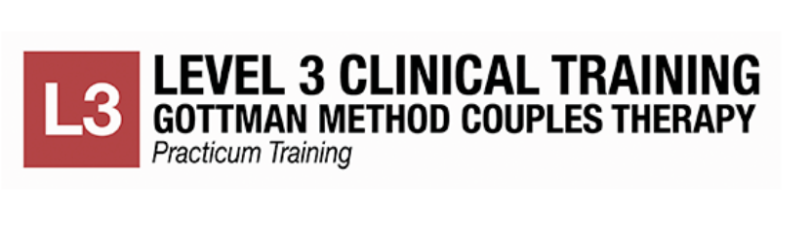 |  |  |  | Can you share a bit about what Gottman therapy is all about?  The Gottman Theory for Making Relationships Work  Build Love Maps: How well do you know your partner’s inner psychological world, his or her history, worries, stresses, joys, and hopes?  Share Fondness and Admiration: The antidote for contempt, this level focuses on the amount of affection and respect within a relationship.  Managing Conflict: We say "manage" rather than "resolve" conflict because relationship conflict is natural and has functional, positive aspects.  Turn Towards: State your needs, be aware of bids for connection and turn towards them.  Make Life Dreams Come True: Create an atmosphere that encourages each person to talk honestly about his or her hopes, values, convictions and aspirations.  Create Shared Meaning: Understand important visions, narratives, myths, and metaphors about your relationship.  Does Bright Hearts take insurance? Yes! We are in network with:  - Regence (Blue Cross Blue Shield)  - Aetna  - Kaiser (PPO Plans only)  - United Healthcare  - First Choice |  |  | 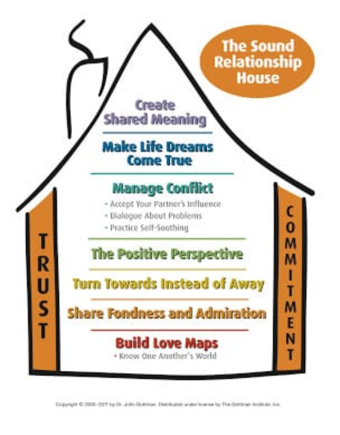 |  | Figure 1a.  Have you or your partner experienced any of the following?  - Sexual or financial betrayal  - Trust damage  - Verbal hostility  - Destructive patterns  - Mental Health Issues  - Domestic violence  - Anger issues  - Hindrances to growth  If so, real help is a phone call away: (206) 679-4321  G

